2D graphics

unit 29

James Noble {IL} [012138]

Year 12

Contents

Illustration 2

Information 3

Education 4

Branding 4

2D Graphics 5

Vector Graphics 5

Bitmap Graphics 5

Differences 6

Platforms 6

Illustration purposes 6

Information purposes 8

Education Purposes 10

## Image result for vector graphics in illustrationIllustration





## Image result for vector graphics in informationInformation

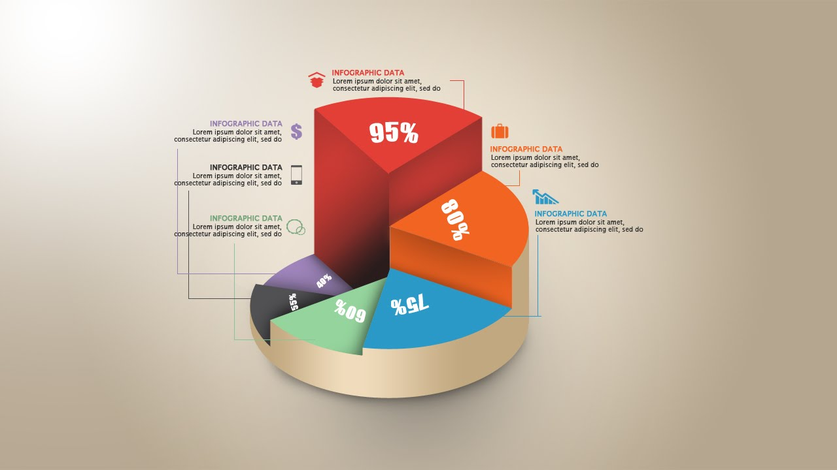

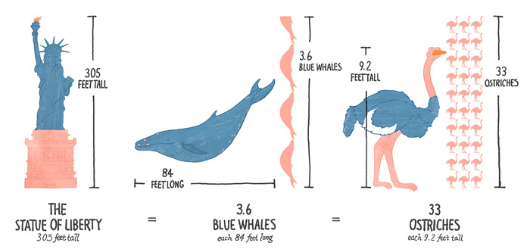

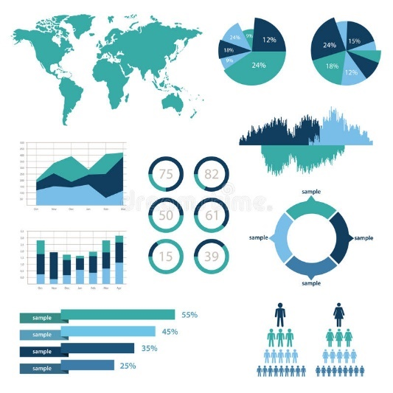

## Image result for vector graphics used in educationEducation

## Branding





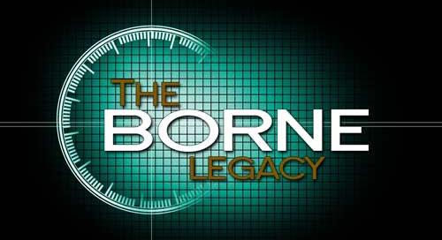

Key:

Colour

Purpose

Vector or bitmap

## 2D Graphics

2D graphics are Computer based generation of digital images. 2D means that the graphics are only two dimensional and are therefore flat, and only work on the x and y axis compared to the x, y and z of 3D. Computer displays only show 2D, however they are capable of showing a 3D model on a 2D plane. 2

## Vector Graphics

Vector graphics are based around objects, meaning that they don’t take up as much space, as the computer doesn’t have to store image which take up space and only has to store the objects that make up the graphics. Each object can be edited while creating the graphics. Vector graphics are often less detailed than bitmap meaning they take up less space. However, this doesn’t mean the quality of vector graphics are lower, it means that the detailing the creator is able to put into the graphics is much less. Vector graphics don’t lose quality as they are scaled up, as the objects get larger in size and don’t pixilate. This means that an a4 sized vector graphic could be digitally scaled up to the size of a building and it wouldn’t lose quality. The graphics are less realistic and are more cartoony, meaning they are frequently used in children’s books as they suit the art style, as well as in advertisements, especially if the advert will be distributed to different formats as you wouldn’t have to completely remake a magazine advert for a billboard, because if it is created using vector graphics then it can just be scaled up without loss of quality. Illustrator is a popular software for creating vector graphics, and is in the adobe software suit. Vector graphics consist of flat fill colours rather than Bitmap which consists of gradients, however bitmap can also have flat fill colours.

The native format that software can read for vector graphics is .svg, however vector graphics are commonly stored as .cgm, .odg, .eps and .xml as well.

## Bitmap Graphics

Bitmap graphics are pixel based unlike vector which is object based. Therefore you can edit the individual pixels which cannot be don’t with vector graphics. The file size for bitmap is often large, as computers have to store the details of the file as individual pixels. Unlike vector graphics, bitmap graphics loose quality when they are enlarged. This is because when you enlarge an image, you are separating each pixel out more. Where this would usually create blank spaces, the program tries to either fill the blank space with black, white or an average of the colours of the pixels around the blank space. This reduces the quality because it blurs any sharp edges. Bitmap graphics are more realistic because they are normally photos that have been taken. This means that the pixels are organised to look like the photo that the user took. Photoshop is commonly used for editing and creating Bitmap graphics. This is in the adobe suit, which costs quite a lot, meaning that the most common bitmap graphic software is actually Microsoft paint, as it’s included with every version of windows currently being sold. Bitmap graphics also have gradients and depth which vector does not.

The native format for Bitmap graphics is .bmp, however other common formats include .dib, .jpeg or .jpg, .gif, .tiff and .png as well.

## Differences

Vector graphics unlike bitmap is object based, meaning where in bitmap graphics you edit each individual pixel in vector you edit and move each object. This may at first seem like a disadvantage, however it’s this which means that vector graphics can be scaled infinitely without losing quality. In bitmap if you scale the file too much, then it becomes burry and loses quality due to the program having to fill the empty space with an average of the pixels around it creating blurry edges, which is not a problem within vector graphics.

The file size of vector and bitmap graphics also varies. In vector graphics, the file doesn’t have to save the location of each individual pixel, but just the location of the object. This means the file size of vector graphics is much smaller of bitmap graphics meaning it takes up less storage space on the system. Bitmap graphics therefore take up a lot more space than vector graphics, meaning more storage is required for them to be kept. This is because the system must store the location of each pixel within the file so that the user doesn’t get pixels out of place.

Images taken on a phone or created digitally are often done in bitmap, as they are more realistic graphics due to the increased amount of detail you can put in them. Vector graphics couldn’t be used for photos as they couldn’t contain the detail required for high quality images, and the sensors used are designed to output an image in pixels rather than objects, because bitmap graphics are more realistic and detailed. Vector graphics are less realistic and often look like images from a cartoon. This is because of the full fill colours and the objects which means that it’s hard to make them look realistic.

## Platforms

Both types of graphics can be distributed in different ways. The most popular distribution platforms are billboards/posters or TV. Billboards and posters are more often stationary, meaning the graphics displayed on them need to transmit their message with one frame. If the illustration is artistic, then this isn’t a massive problem as you just need to put your art onto the distribution method, however if the graphic has to show the viewer something, such as statistics or an event line-up, then the graphic needs to be able to show the viewer this in one frame as that’s all they have with a stationary platform such as billboards or posters. Electronic billboards have started to become more popular recently, meaning people wishing to distribute their content onto them can use videos or gifs instead of stationary prints. This means the graphics can be animated, and it also means that not all the content needs to be put onto one frame as there can be hundreds of them to display the content onto. Electronic billboards are often seen in cities, meaning lots of people will see them.

Graphics can also be displayed onto TVs, within the advertisement period on TV channels. You get a set amount of time in which you can display your content, meaning you must ensure that you can fit all the necessary content within that time. They operate much like electronic billboards, except the TVs are in peoples homes meaning the advertisements can become a lot more personal, and as what’s being said is within someone’s home the viewer might equate it to a friend recommending something to them which might make them more likely to attend the event you are hosting, or to buy the product you are trying to sell.

## Illustration purposes

Illustration 2D graphics are more creative compared to information or education graphics. They can be used for logos, branding, promotional materials signage, web banners or buttons, games, Gifs, or mobile apps.



The purpose of this vector graphic is to provide an image for the brand AT&T. AT&T is a mobile service provider which operates primarily in the USA (United States of America) however it also provides worldwide coverage for customers who are on holiday. It does this by using a logo, being the blue circle. The circle could represent the world which could suggest that the brand has a worldwide effect and has worldwide coverage. As this is the face of the brand, it has to look appealing and modern as outdated graphics or unappealing graphics could turn away potential customers, because more often than not a business that looks unappealing from the outside also provides lesser products or services than alternatives. This particular logo is a vector graphic, which is useful for the brand as it means they can scale it to whatever size they want, meaning if they were to put this on a billboard that’s going to be very large, the logo won’t loose its quality which will make it consistently clear and not pixelated. The bold block colours and lack of intricate detail suggests that this is a vector graphic because vector graphics often use block colours rather than gradients and are made using objects which are unable to created photorealistic graphics. Because it’s a vector graphic, it can also be put onto other promotional products, such as stationary without losing quality.

 This bitmap graphic was designed to show people who want to go to the download festival who will be playing when they go. the fact that this image is a bitmap doesn’t impact massively on the quality of the poster, as its unlikely that it will be scaled massively to different sizes, and the image itself if usually very high resolution meaning the drop in quality when scaled up isn’t noticeable unless you really look out for it. it could also be said that a lot of the people who are going to be interested wont care about the quality of the poster and will care more about the people going, so as long as the poster is still readable it’s unlikely a lot of people will complain about the quality.

The design meets the target audience because it includes logos of the bands that people are interested in, if they are already looking at this poster. The bands going to this event often are very popular, so the more popular of the bands attending the event are positioned at the top of the poster with the lesser known bands at the bottom. Therefore, the logos of the better-known bands will draw in potential attendees as they would recognise the logo and therefore be more interested in the event. I think the graphic’s design meets the target audience well. As the event is a rock/metal festival, the people going are going to be more interested in dark moody colours rather than bright cheerful ones. Therefore, the colours on the poster match the target audience well, as the poster has a black background with a snake on it, with contrasting red and white text. This means the poster is easy to read but also targets its desired audience well. Including popular bands also targets the desired audience as the bands on the poster are either rock or metal orientated meaning the people who want to see those bands are also the target audience, and seeing them on the poster will draw them in.

## Information purposes

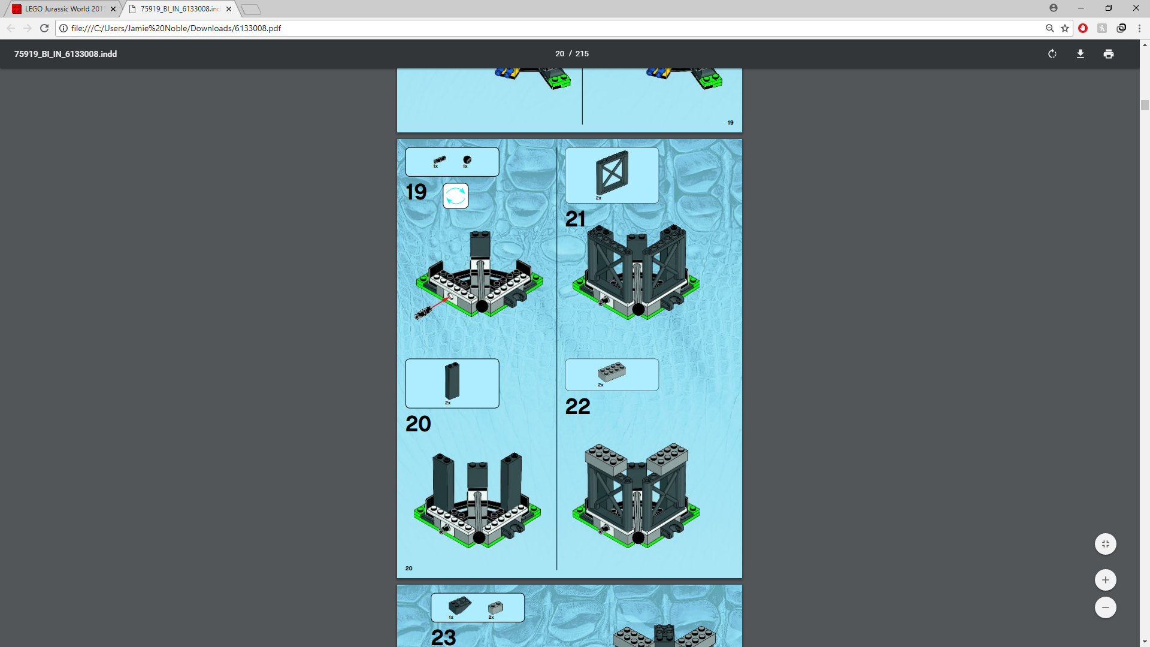this graphic was designed to show people how to construct the Lego set they have bought. Therefore, it is required to show the reader how to construct their Lego set in a clear way so that the reader doesn’t get confused. Therefore, the target audience for this graphic is people who have bought the Lego set and are therefore interested in Lego. The graphic is a bitmap graphic, because although the graphic was designed on a computer, the images of the Lego were previously 3D modelled, and images of them could not be outputted as vector graphics and therefore must be bitmap. This is also seen because the image appears blurry and has not scaled well. The graphic communicates what you user needs to do well, and the instructions are clear. However, Lego instructions are known to sometimes be very unclear, however this one in particular is not. The instruction manual is able to fit 4 steps on this page, however for some of the larger steps they sometimes require more space on the page and therefore 4 on every page is unlikely. The page includes what parts you need for each step, as well as their model number in case you need to contact Lego support to request they send you a missing piece. This makes the instructions easier to follow as you don’t have to guess which piece to use by looking at the image. The image meets the target audience expectations as it allows them to clearly follow the instructions to build their Lego set. I don’t think the designer purposefully chose bitmap, as it was their only option due the graphics being 3d modelled. However, I think that given the chance they would choose to use vector graphics because they can be scaled meaning they could make larger images on each page without loss of quality.

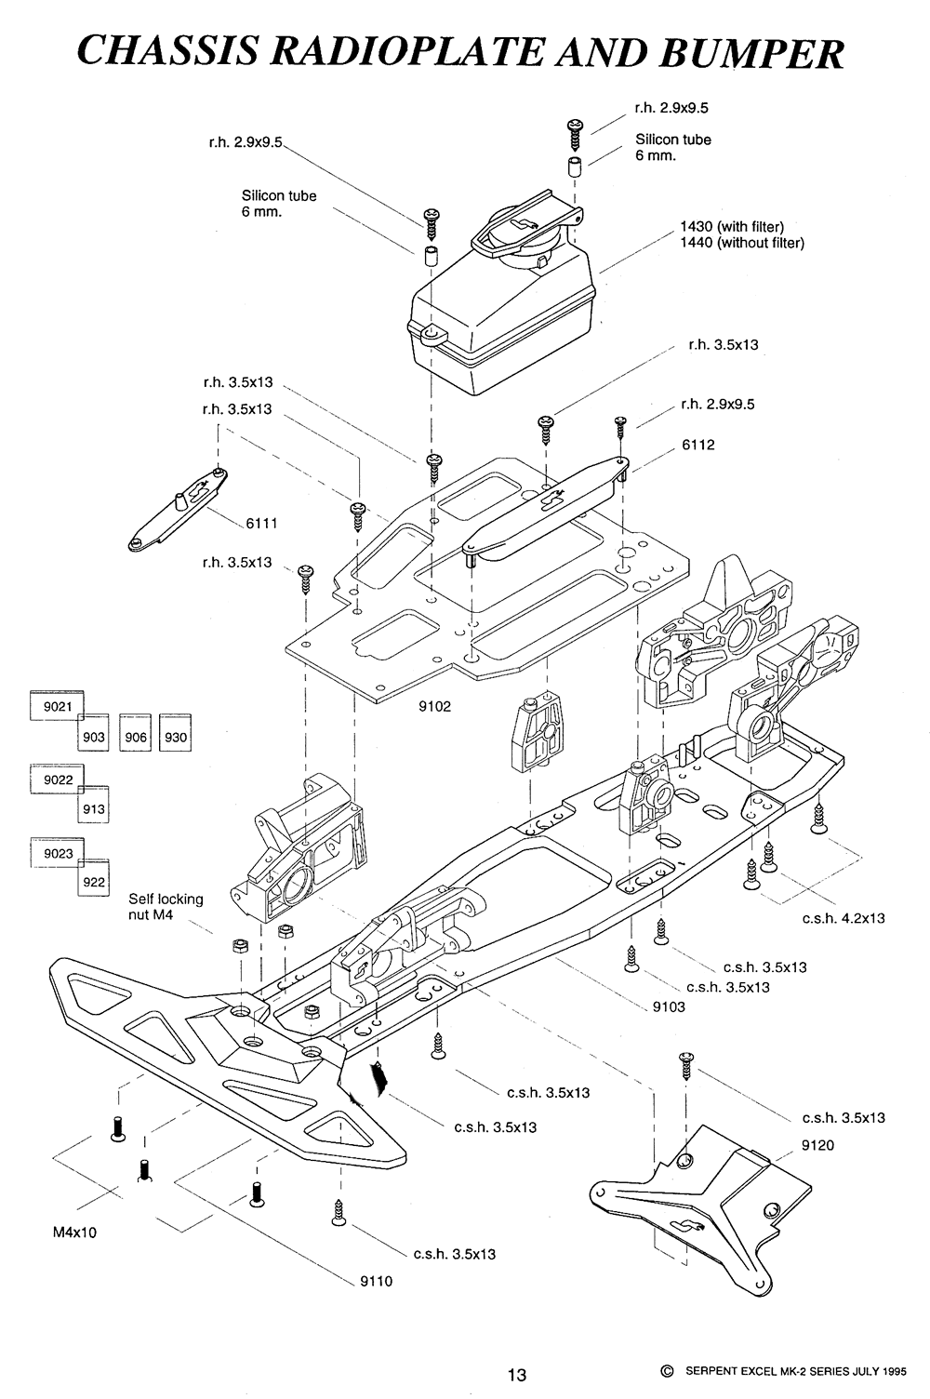this information graphic is designed to show how a component of a car fit together. This allows people to understand how its constructed in the event that the section that’s depicted needs work doing to it which would require it to be dismantled. It does this by showing each component separately and drawing lines which show how each screw connects the parts together, while showing the part number of each part so that its easy to look up and find replacements for that part. The graphic is a bitmap, which was done because the image requires large amounts of detail and was made for only one purpose meaning the ability to be scaled up and down was unnecessary. The amount of detail on the graphic gives away that it’s a bitmap as it would be nearly impossible to get that level of detail using objects and lines. The design is very effective as it clearly shows how the different components go together making it easy to understand how to dismantle and assemble the area. this means there would be less frustration when following the guide, which could lead to the viewer trying to find another. The target audience for this graphic would be people who are interested in or have to take apart this part of a car. Therefore, this graphic meets the target audience as it clearly depicts how the part goes together making it simple for the user to follow.

## Education Purposes

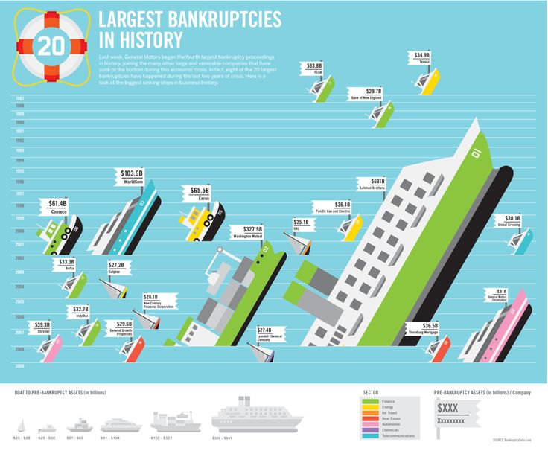

This vector graphic is designed to show the viewer in an attractive way what the largest bankruptcies in history are. the graphic looks as if it was designed to be printed out onto a poster to be put on a wall, possibly within a school where they are trying to educate you about the world. Therefore, it suits its target audience well because its educating the viewer in an attractive manner which makes the poster nice to look at but also conveys the information clearly meaning people won’t get confused about what its trying to say. the graphic has a theme which is the ocean and uses the size of the boats to allow the viewer to visualise the cost and then puts a tag onto the boat saying what it was and how big the bankruptcy was. This makes the graphic easier to understand as it allows the viewer to visualise the cost. I can tell that this graphic is a vector graphic due to it having characteristics of the vector graphics, such as the bold colours used, the lack of precise detail on the boats and the graphics not looking photorealistic like bitmap graphics do. This means the poster can be scaled up to any size meaning it wouldn’t lose quality when printed into a poster. This means that the poster can be made as big or as small as needed. Its likely that the designer used vector graphics for this reason, as they must have known that the graphic was going to be used on a poster. The simplistic art style that vector graphics often brings with it also makes the poster look quite visually pleasing.

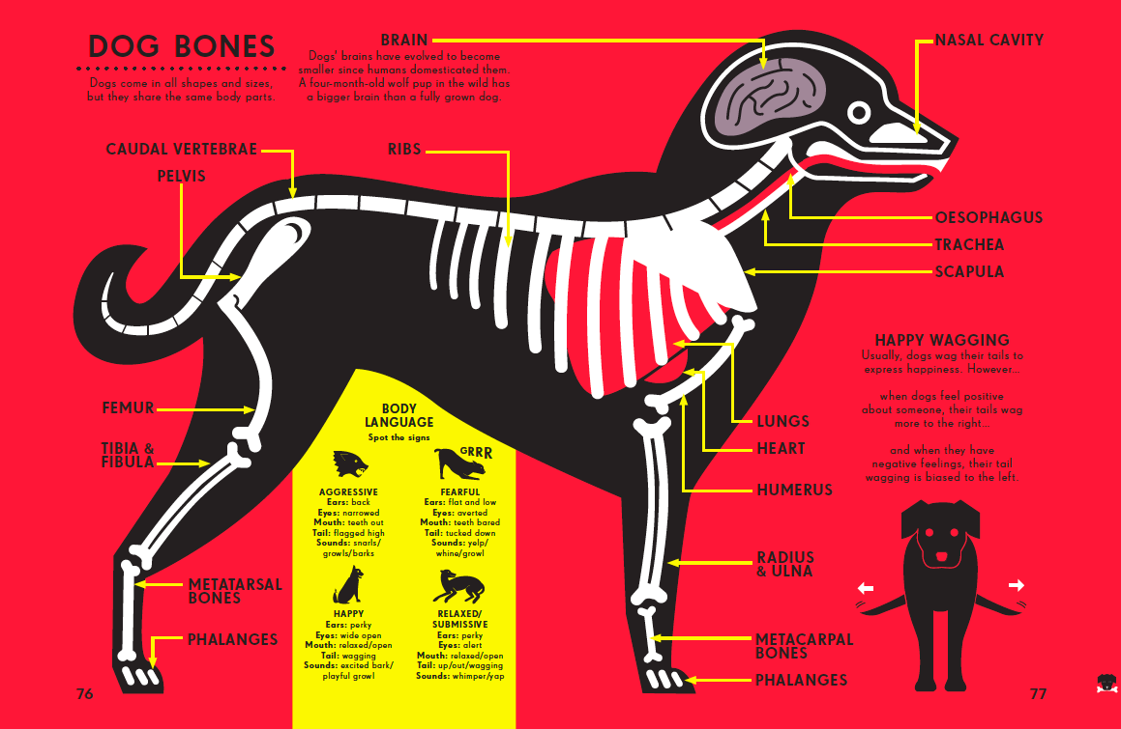

The graphic was designed to educate the viewer about the bones and body language of a dog. I think the graphic is targeted more towards children as its very stylised and quite simplistic as to not overwhelm them with knowledge. I think it conveys its content effectively, as the sans-serif font it easy to read and contrasts well with the background, and the graphic quite clearly depicts the bones within a dog without using a photorealistic graphic of a dog, as seeing the bones of a real dog could end up being quite traumatic for the viewer, especially if the viewers are quite young. The bright red background draws the viewers attention towards the graphic but doesn’t take away from the dog in the middle as it uses contrasting colours to show up well. For example, the main outline of the dog is in black, with the bones in while and organs red or dark purple. All of these colours contrast well together and don’t blend making them stand out clearly. The dog appears to have similarities with a Labrador, which is one of the most popular dogs in the world, meaning a higher percentage of people will understand that what applies in this poster would also apply to their pet if they owned a dog. Arrows are used to point to the different bones from their tags to show what each one is called. This graphic is clearly a vector graphic. This is because it uses bold colours with no gradients, and all of the lines are very smooth with a lack of detail. The dog does not look photo realistic as this would require it to be a bitmap graphic. I think the maker created it using vector graphics so it looked stylised and visually attractive, however I think they also did this so the graphic can be scaled to any size allowing it to be on any size of poster giving it more flexibility when it came to printing, such as being able to fill an entire billboard without losing quality or being able to go to go to an a4 poster and still be readable. I think the graphic does what it was designed to do well and meets the target audience’s expectations well, as its able to educate people about the bones within a dog, as well as relate to dog owners in an attractive and clear way.